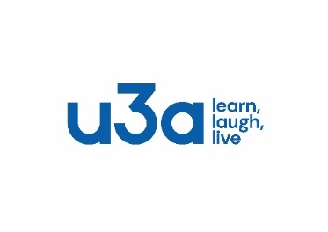
u3a Blyth and District

DAY TRIPS 2026

Auckland Palace, Faith Museum and Gardens
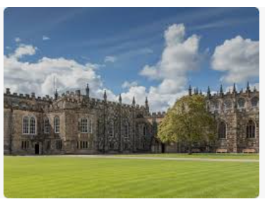
Date: Wednesday 25th March 2026
Time: TBC
Cost: £40

Visit one of the best-preserved bishop’s palaces in Europe, connect with nature in the stunning Walled Garden and extensive parklands and discover stories of faith in Britain spanning 6,000 years.
Please register your interest and pay a deposit of £10
Final Balance to be paid at February’s meeting (27 Feb)

Knaresborough

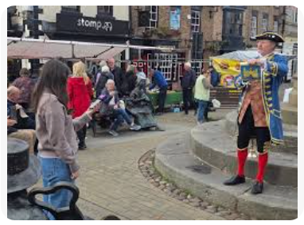
Date: Wednesday 20th May 2026
Time: TBC
Cost: £30 (approx.) Cost of bus only

Visit this historic spa town in North Yorkshire with free time to explore its medieval streets and ever-popular market on Market Day. With stunning scenery, Victorian viaduct and castle ruins there will be plenty to do, unless you want to just relax with a cup of tea and delicious home baked treats.
Please register your interest and pay a deposit of £10

Later in the Year……
Berwick by Train (August)
Christmas Market at Raby Castle (November/December)
Look out for details on the Notice Board.

